Python Programming

Experiment Report

Name DIO STANIA ADINATA
Student Number
Major Software Engineering
Class 2023

2022

Experiment 6

Experimental Purpose
Experiment 6 aims to deepen the understanding of Python programming through the following objectives:
  - Master the usage of Nested Structure through coding.
  - Master the usage of Loop Structure through coding.
  - Mastering the definition and usage of the functions through coding.
  - Mastering how to pass parameters for functions through coding.
- Experiment Content
  - Objective1: Day of the Week
    - Design thought
I plan to create a asks the user to enter a number between 1 and 7. By using an if-elif-else structure, it will maps the number to the corresponding day of the week (1 = Monday, …, 7 = Sunday), and if the number is outside this range, an error message will be displayed instead.

Source Code
number = int(input("Enter a number (1-7): "))

if number == 1: print("Monday")
elif number == 2: print("Tuesday")
elif number == 3: print("Wednesday")
elif number == 4: print("Thursday")
elif number == 5: print("Friday")
elif number == 6: print("Saturday")
elif number == 7:

print("Sunday") else:
print("Error: Number must be in the range 1 through 7.")

Experiment Result
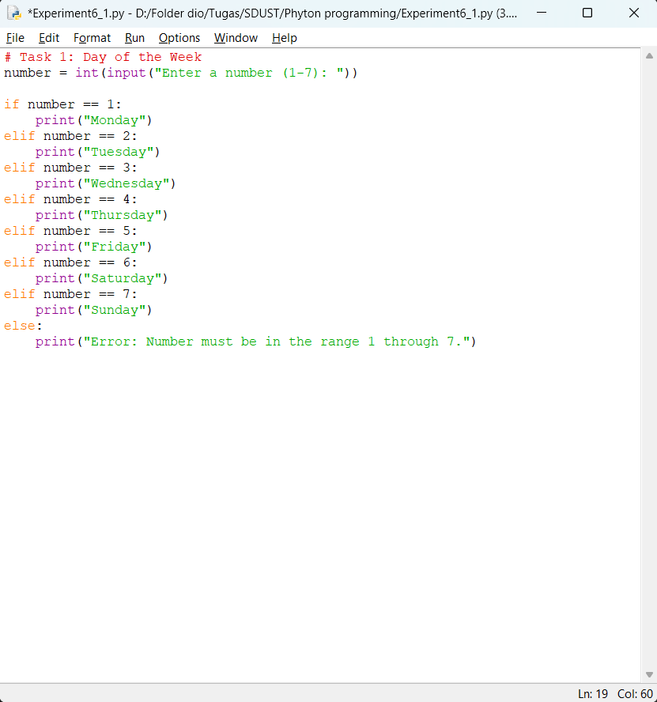

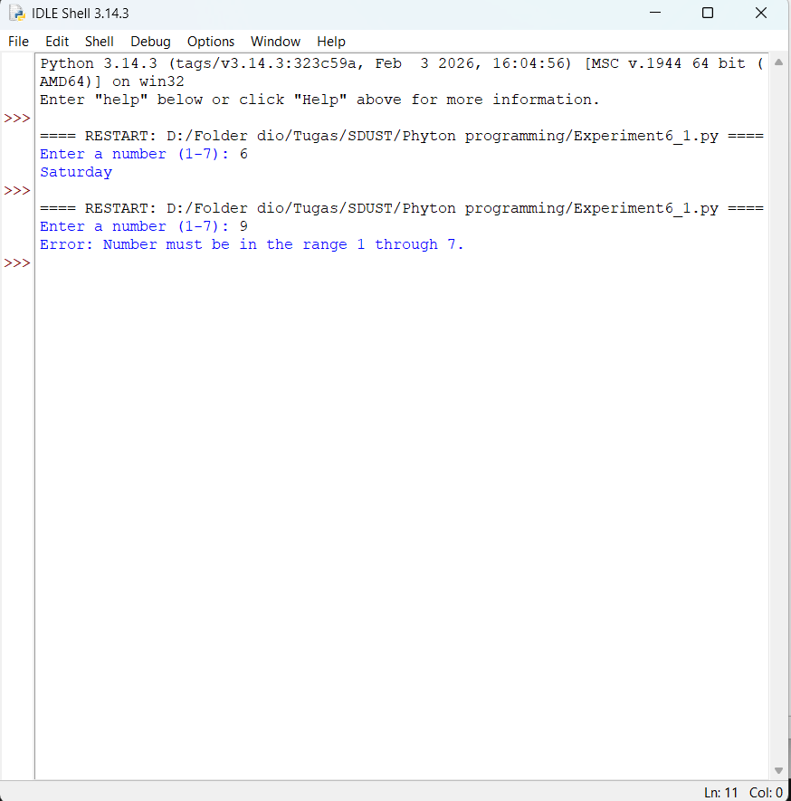

Objective2: Most Frequent Character in a String
    - Design thought
I plan to create a program that takes a string input from the user. The program will counts the frequency of each character using a dictionary. After counting, the program will finds the character with the highest frequency and prints both the character and its count. If there are multiple characters with the same maximum frequency, only the first one encountered is displayed.

Source Code
text = input("Enter a string: ")

if text:
freq = {}
for ch in text:
freq[ch] = freq.get(ch, 0) + 1

max_char = max(freq, key=freq.get)

print(f"The most frequent character is '{max_char}' appearing
{freq[max_char]} times.") else:
print("Empty string entered.")

Source Code
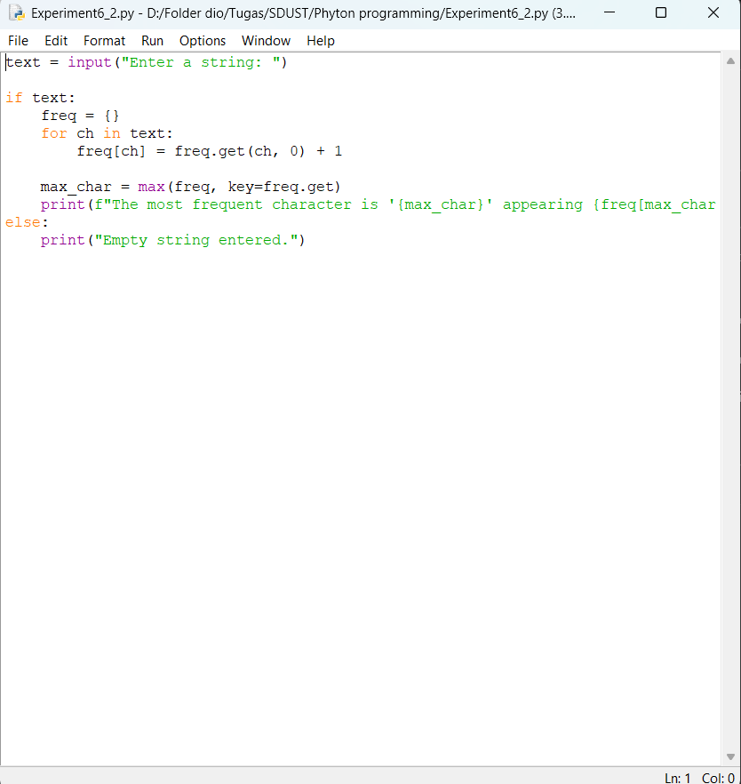

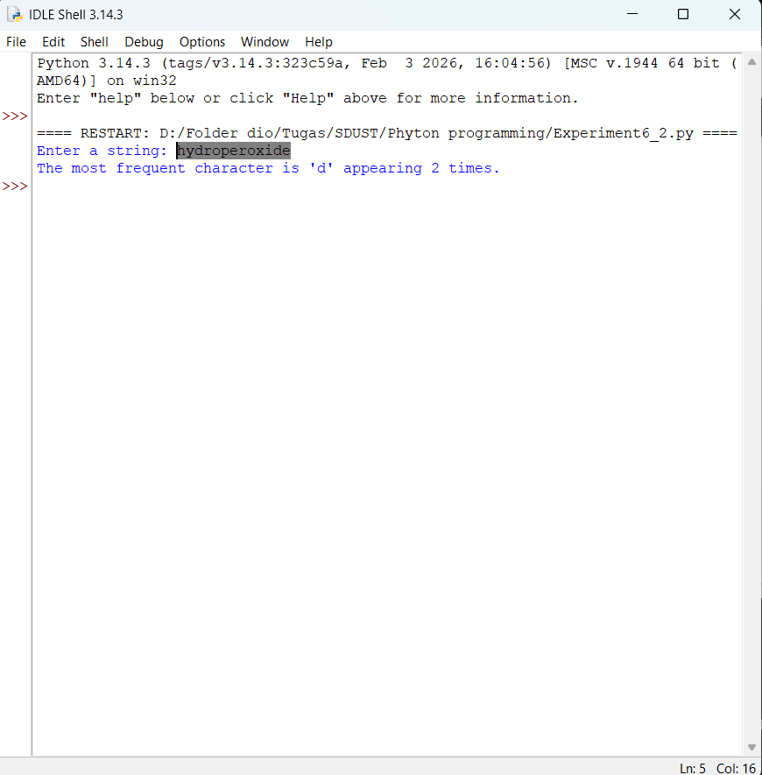

Objective3: Drawing a Pattern with Nested Loops
    - Design thought
I plan to create a pattern that consists of 7 rows. The first row has 7 stars, the second row has 6 stars, and so on until the last row has 1 star. Using an outer for loop to control the row number (from 7 down to 1) and an inner for loop to print the correct number of stars for each row.

Source Code
rows = 7
for i in range(rows, 0, -1): for j in range(i):
print("*", end="")
print() # move to next line

Experiment Result

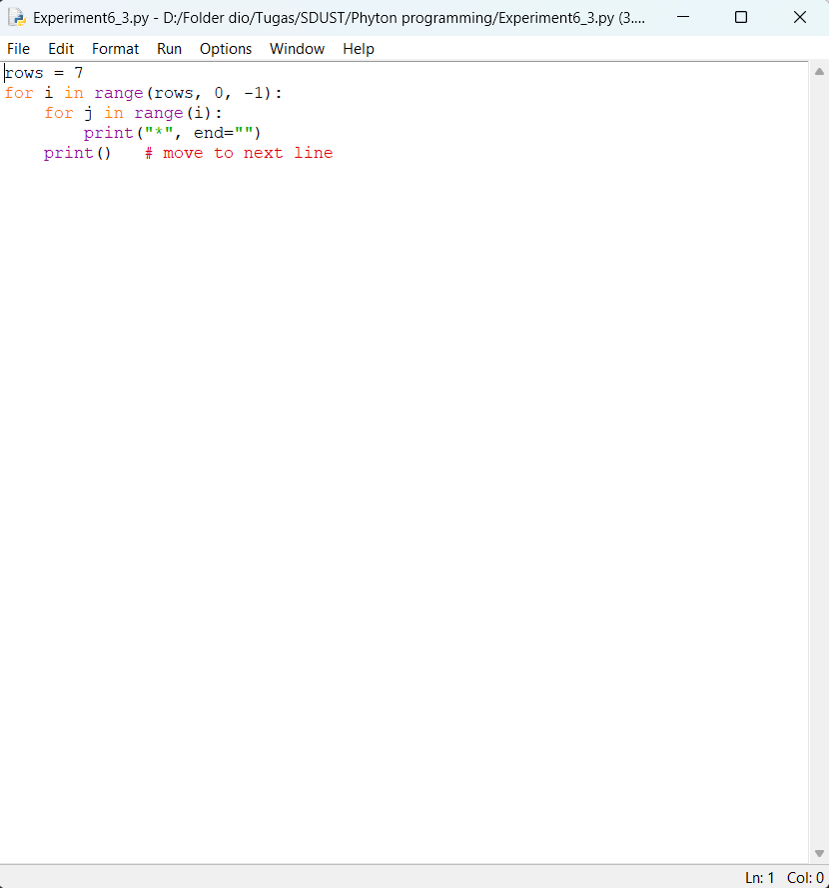
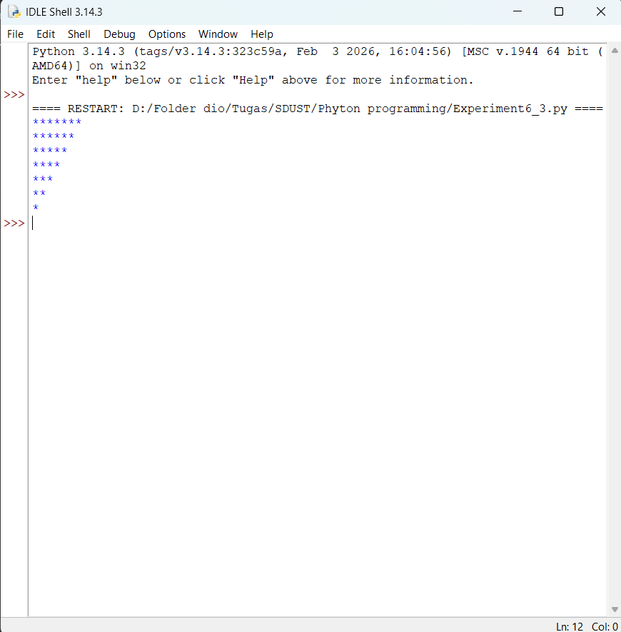

Objective4: Function to Add Two Integer

    - Design thought
I plan to create a function named Addition(). it is defined that takes two integer parameters, calculates their sum, and returns the result. The program then asked the user for two integers, calls the function, and prints the result.

Source Code
rows = 7
for i in range(rows, 0, -1): for j in range(i):
print("*", end="")
print() # move to next line

Experiment Result
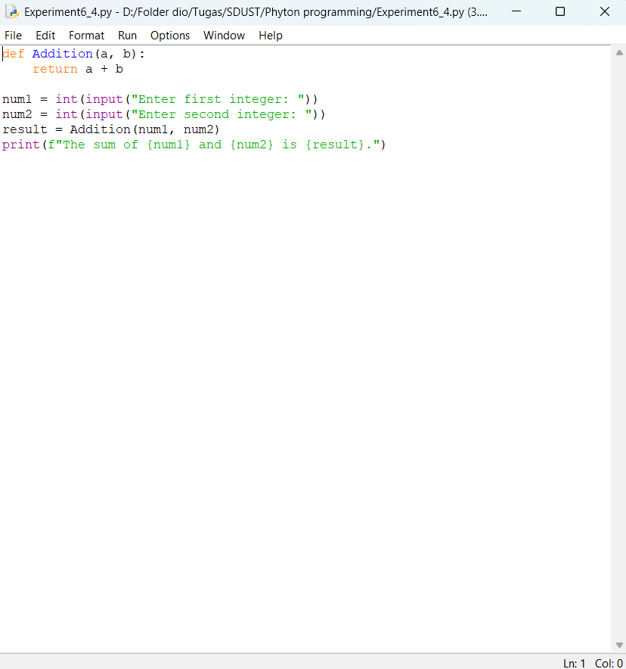

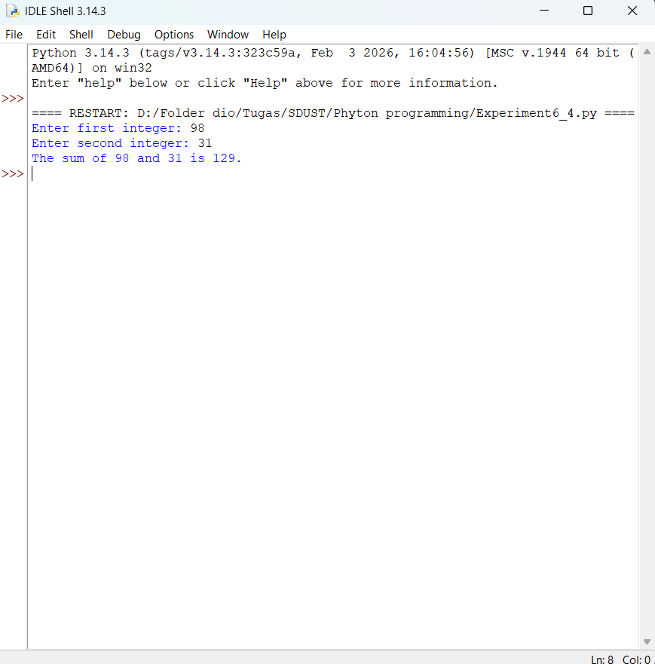

Objective5: Function to Combine First Name and Last Name
    - Design thought
I plan to create a program that asks the user for their first name and last name, it will storing them in two variables. A function named your_name() is defined that takes these two variables as arguments, concatenates them with a space in between, and returns the full name. The result is then printed.

Source Code
def your_name(first, last): return first + " " + last

first_name = input("Enter your first name: ") last_name = input("Enter your last name: ") full_name = your_name(first_name, last_name) print("Your full name is:", full_name)

Experiment Result

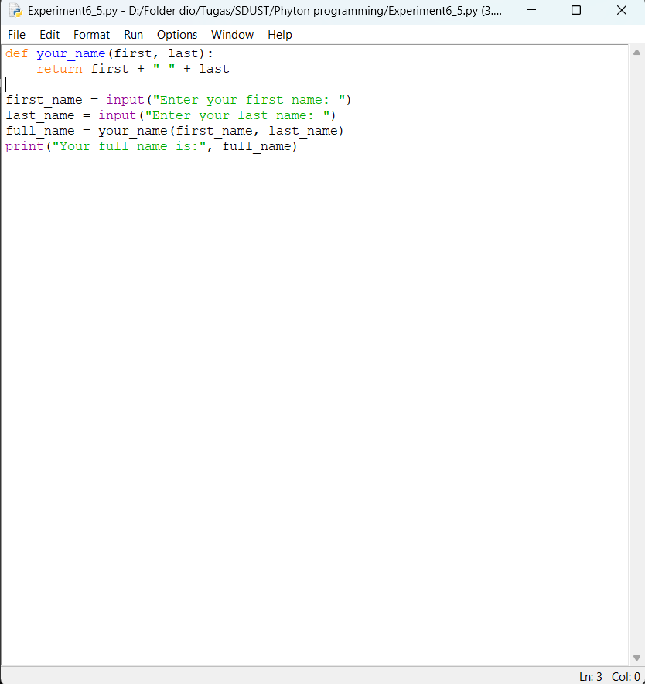
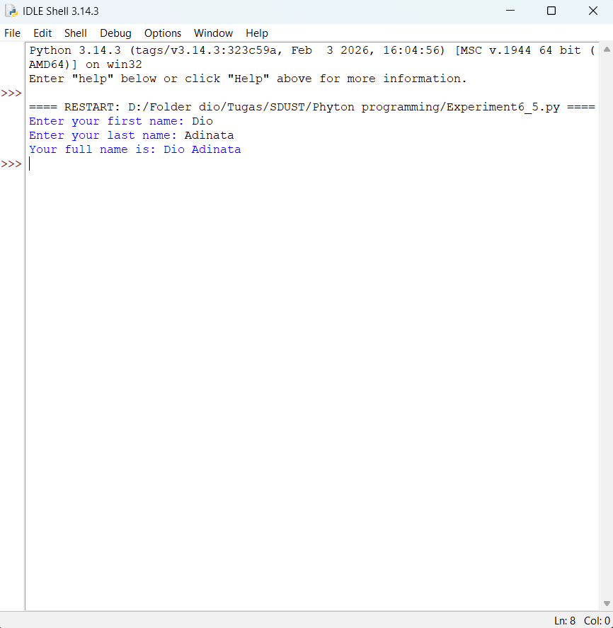

Experiment Conclusion
What did you learn from the experiment?
From this experiment I learned several important concepts in Python programming. I learned how to use nested decision structures to map numbers to days of the week and handle invalid input. I also learn how to use loops and dictionaries to count character frequencies and find the most frequent character in a string. By using nested loops, I was able to generate a decreasing star pattern, which reinforced my understanding of loop control and iteration. Lastly i learn how to perform specific tasks, such as adding two numbers and combining names.

